MYM Assignment

Step 1 :

start the node js server by using npm start command

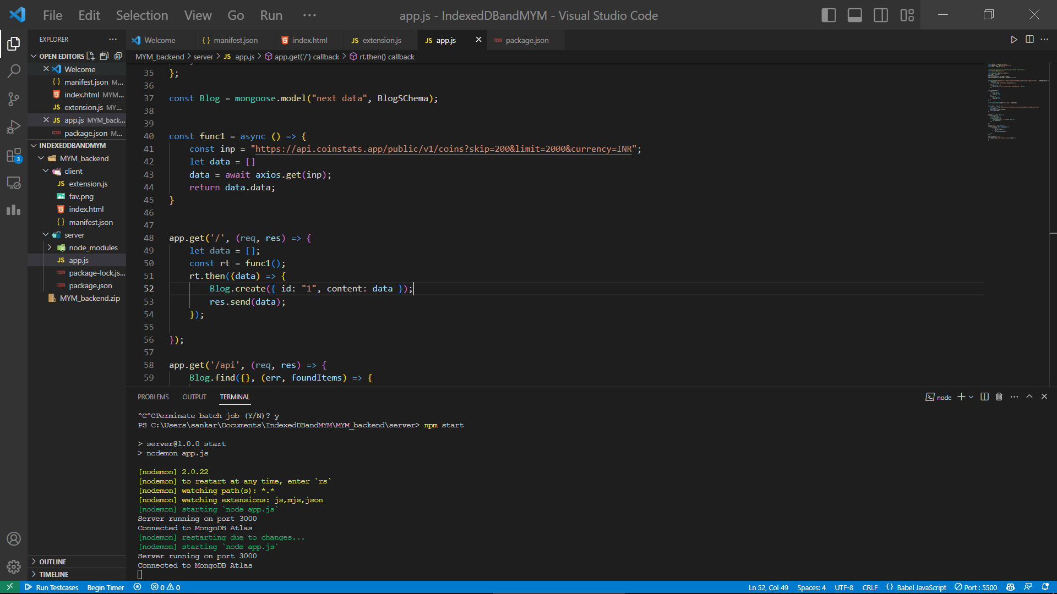

Step 2:

Click on the load unapcked

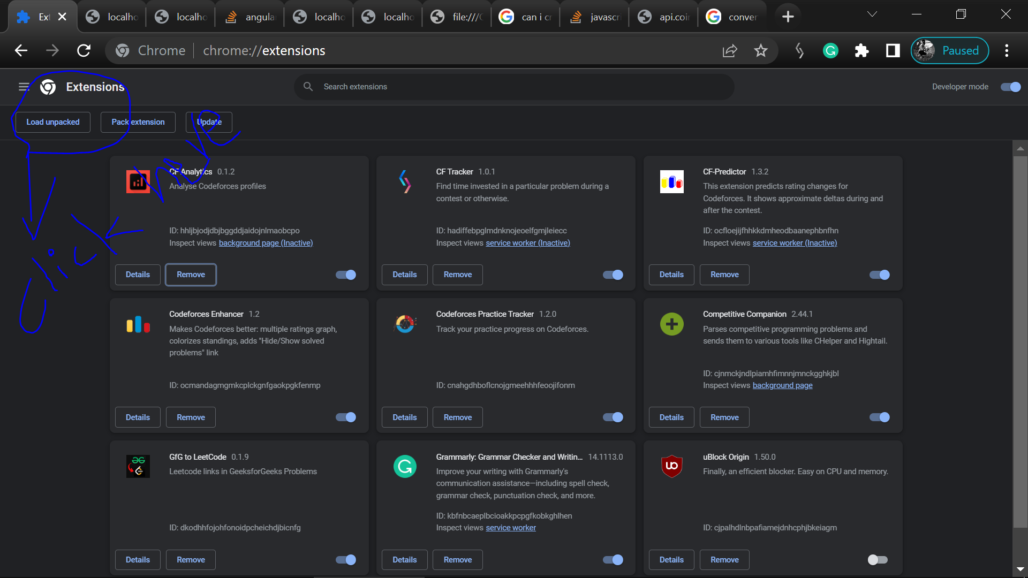

Step 3 :

Select the client folder

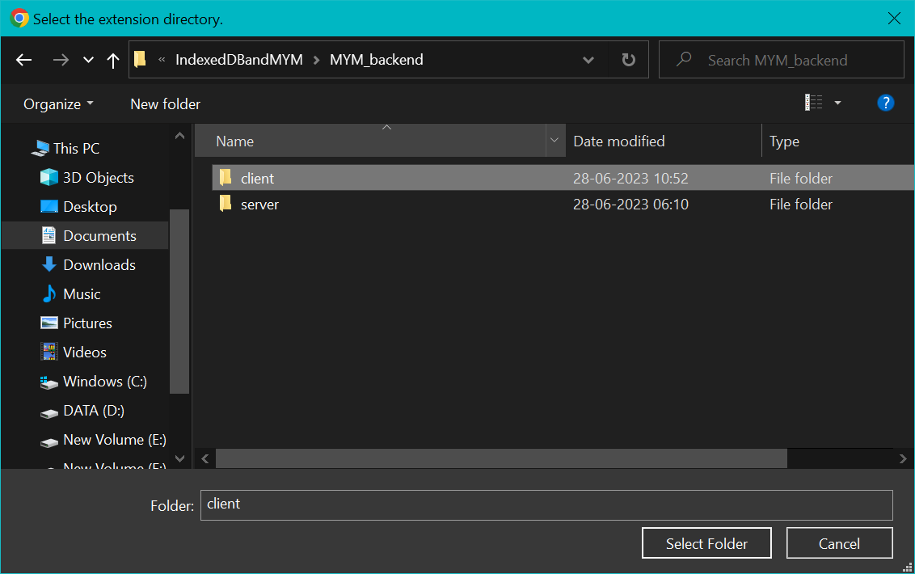

Step 4 :

Click on the extension

After clicking on the extension we can find the button with “fetch the data”

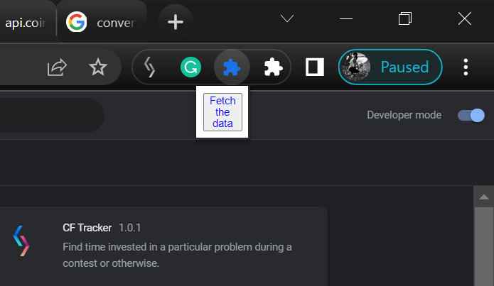

Step 5 :

Click on the button and you can get some data with 200 data, that is stored for the first time and fetched everytime from indexedDB

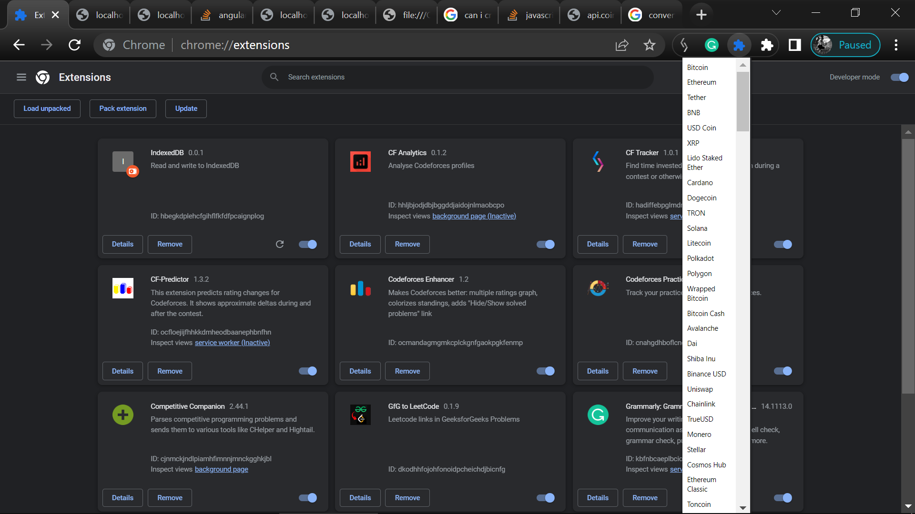

After some time we can find that, we are fetched the data with 2000 list of data, that is stored first time on the mongodb atlas cloud and fetching everytime with indexedDB data

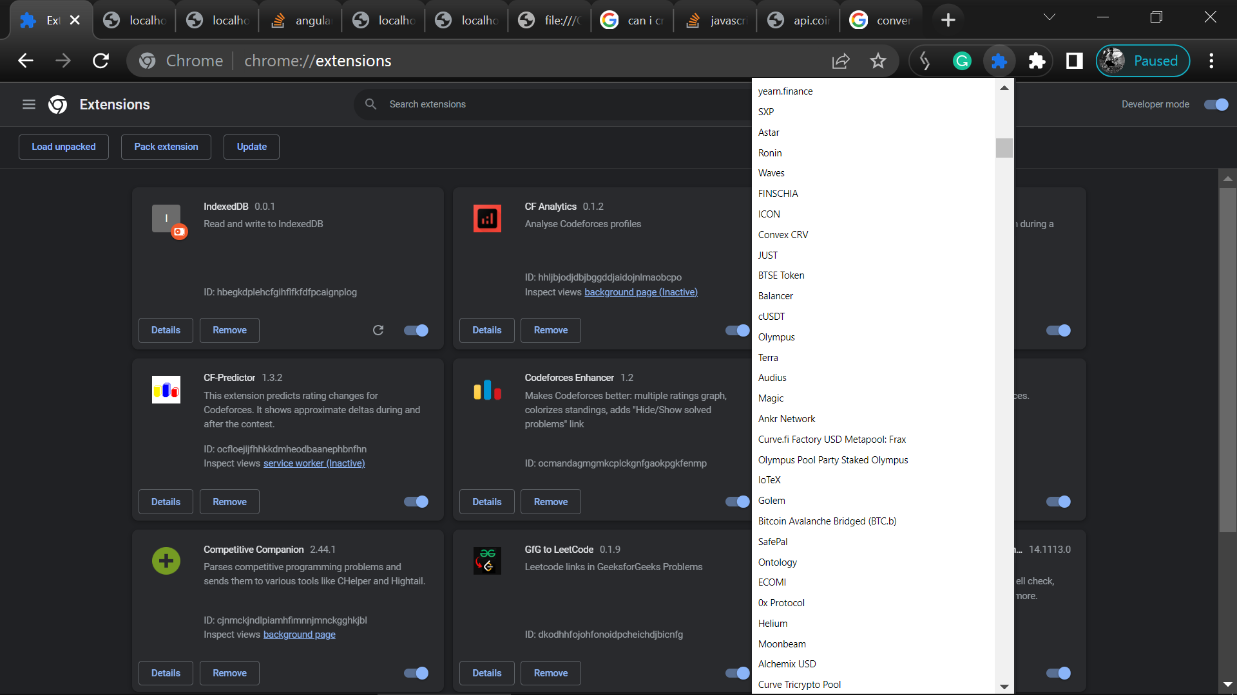

Results :

WE can find that that, the data is stored in indexDB (list of 200 )

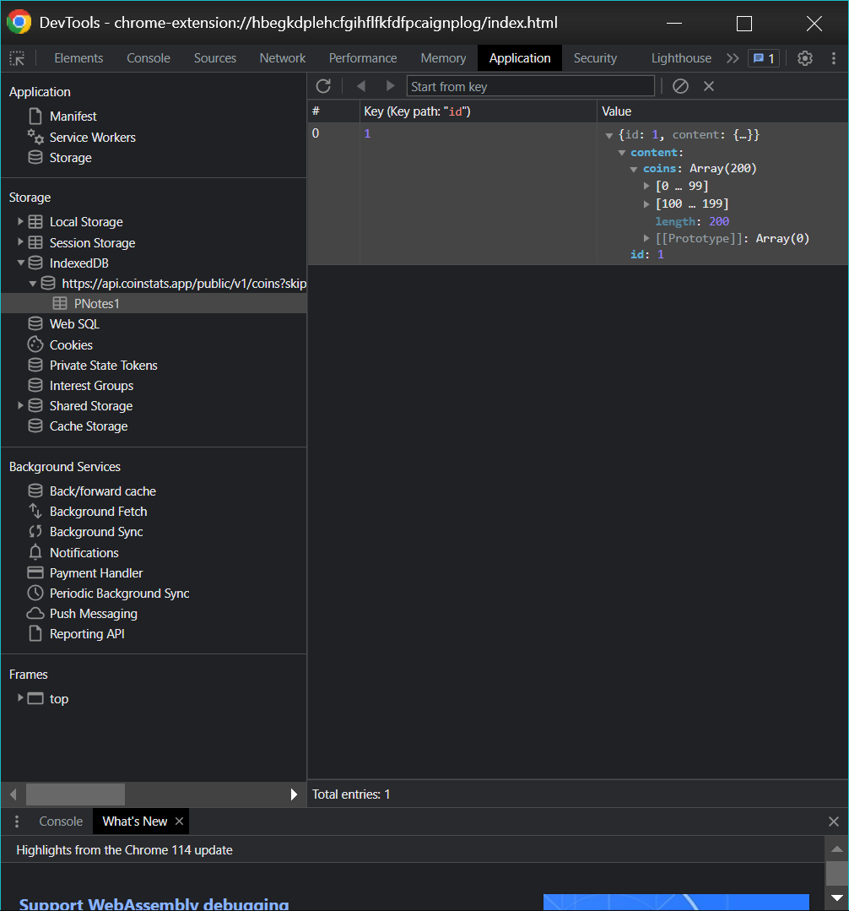

Remaining 2000 data is stored in MongoDB cloud

